HOSPITAL MANAGEMENT SYSTEM

USECASE DIAGRAM:

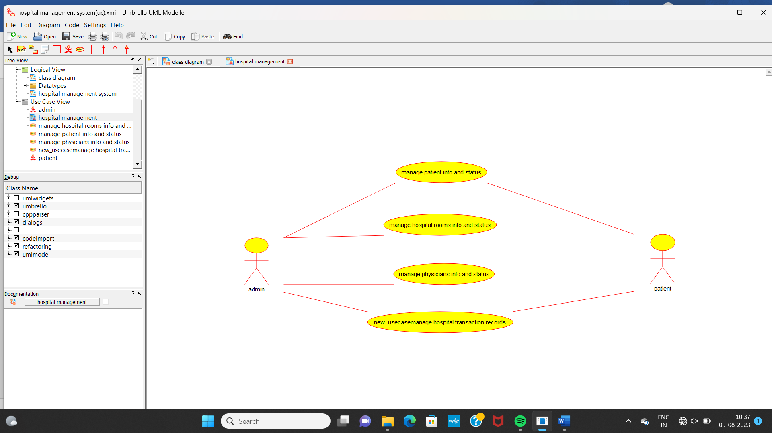

CLASS DIAGRAM:

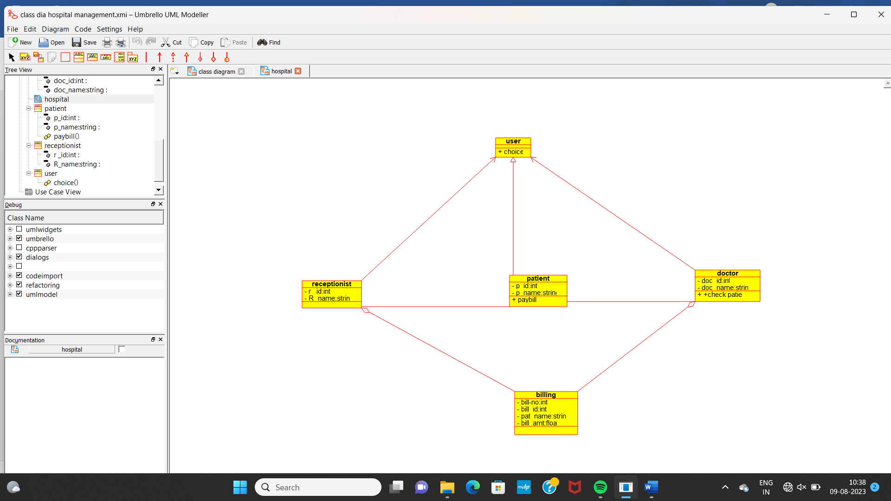

ACTIVITY DIAGRAM:

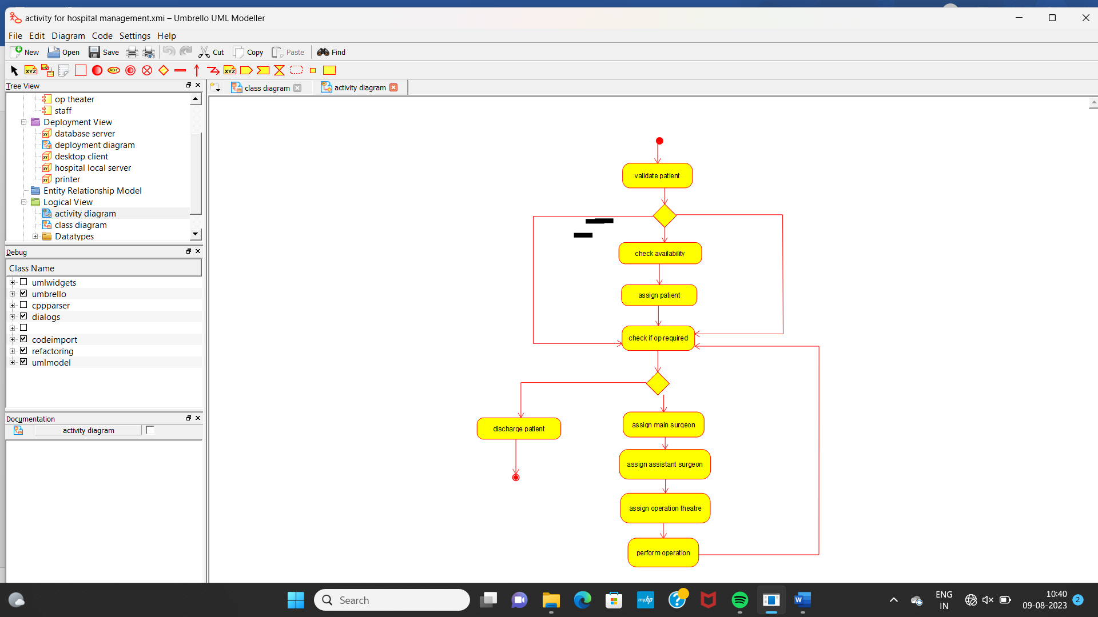

COLLABARATION DIAGRAM:

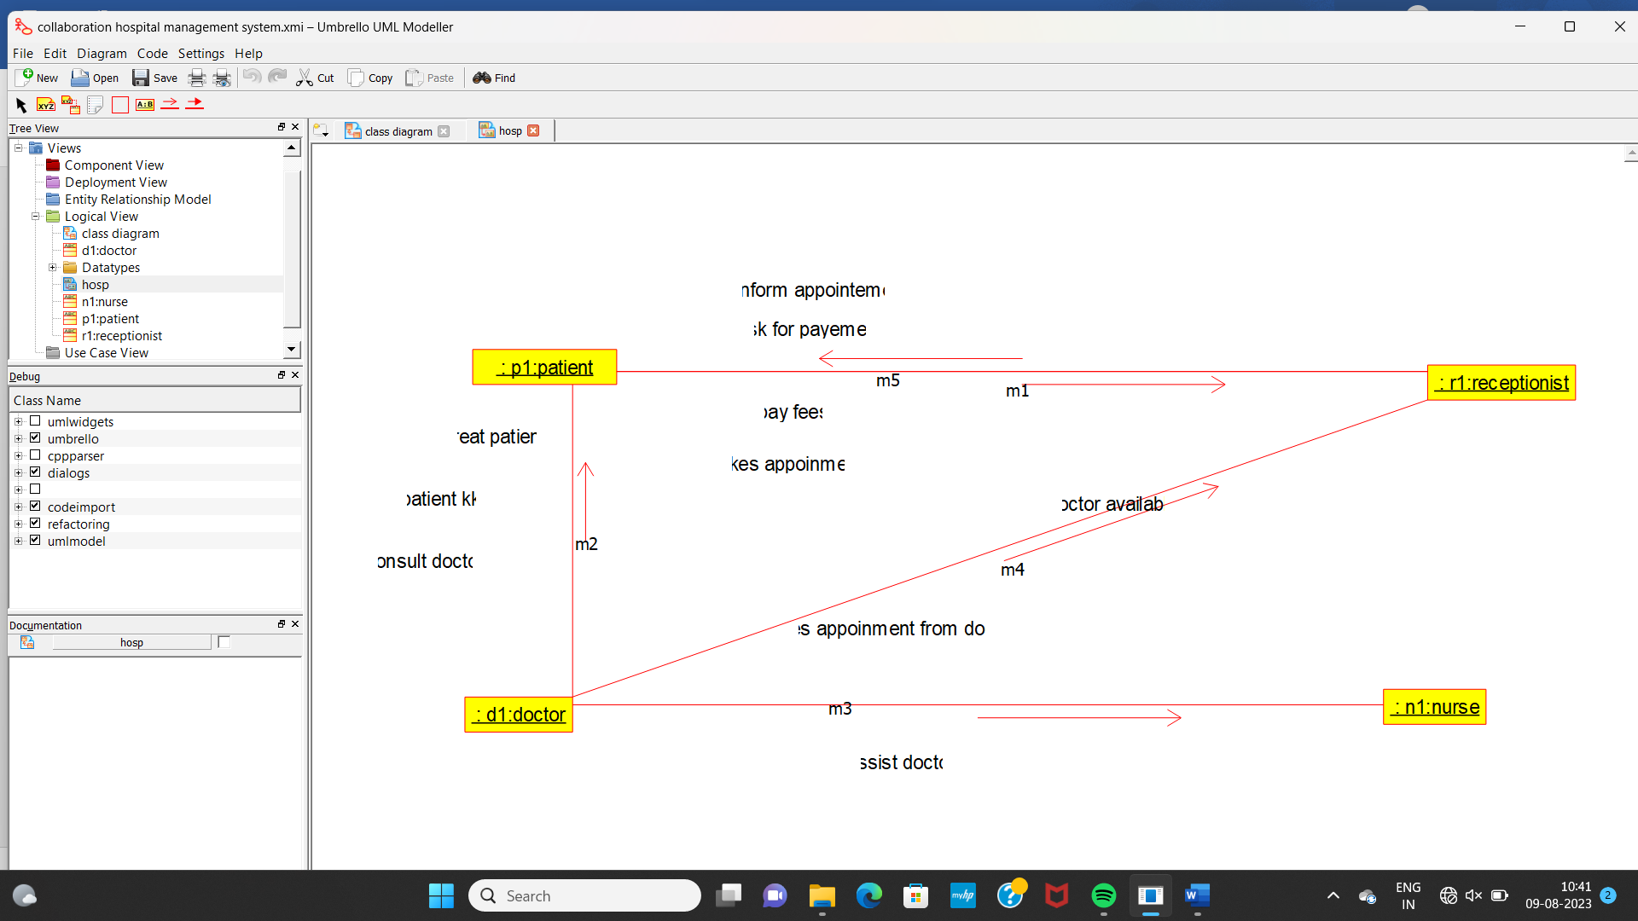

COMPONENT DIAGRAM:

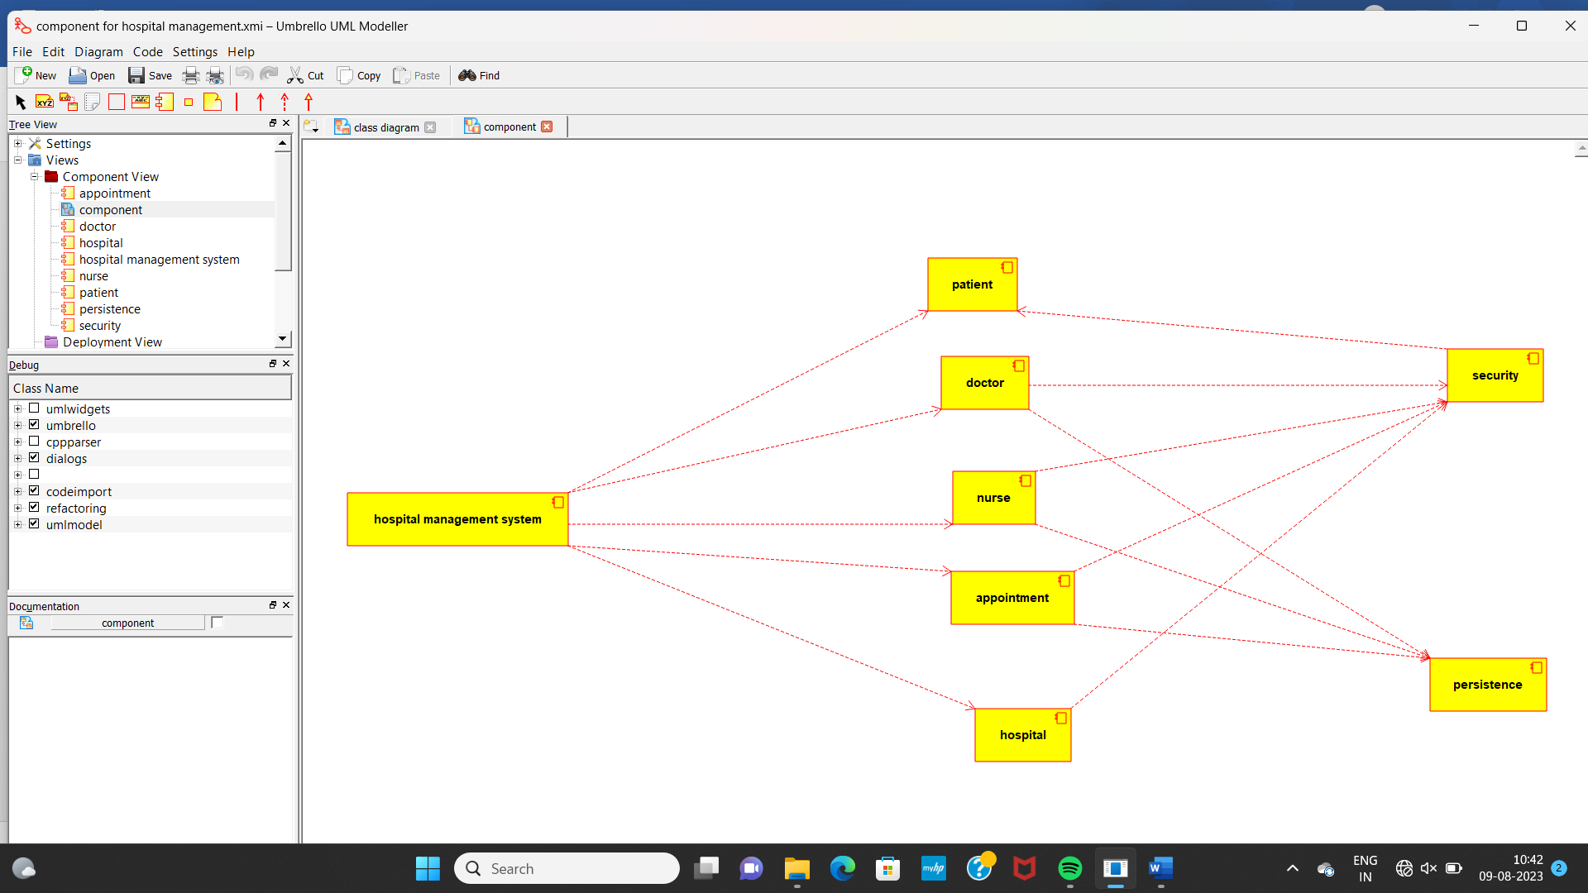

SEQUENCE DIAGRAM:

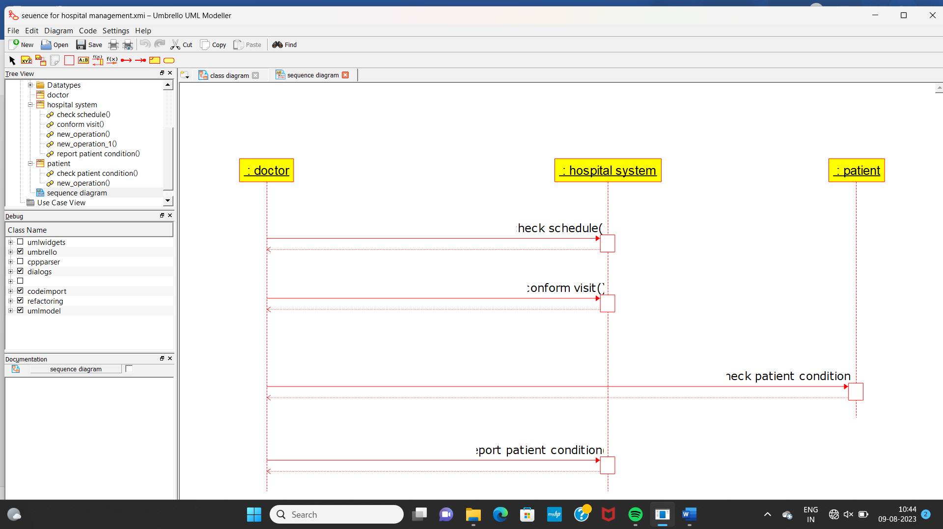

STATE CHART DIAGRAM:

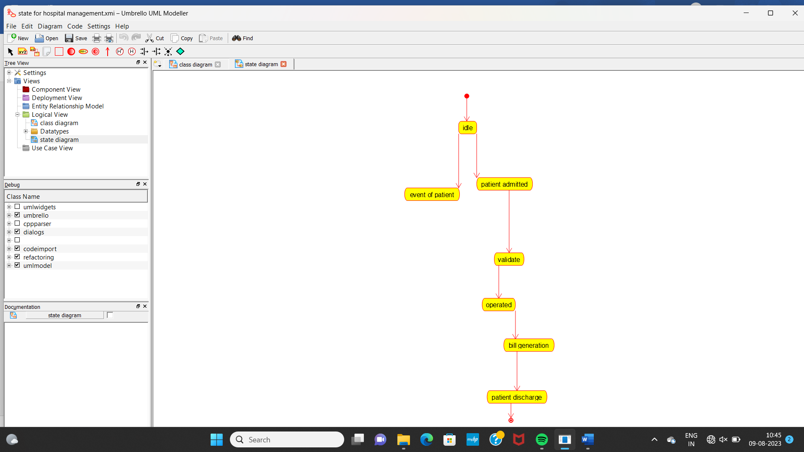

PACKAGE DIAGRAM:

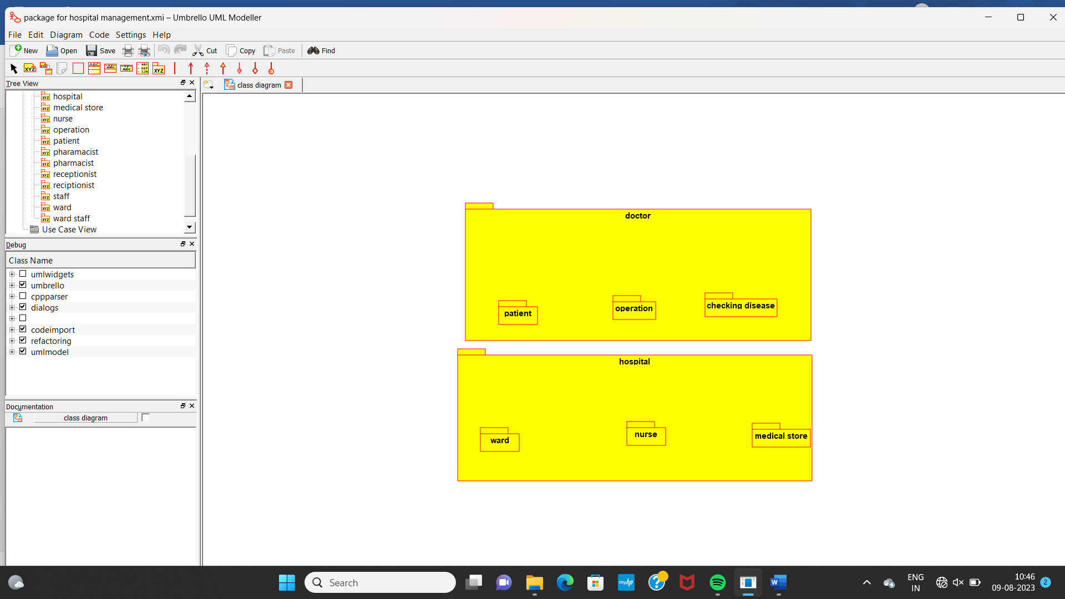

DEPLOYEMENT DIAGRAM:

